The purpose of this analysis is to present data-driven recommendations to Management for increasing market share through more effective acquisition, annotation, and targeting of leads. The dataset used for this analysis is a comma delimited file of 133,676 rows over 30 columns with each row representing a single lead.
The following marketing funnel shows the number of leads created in the last ten months that have progressed to Prospect, Opportunity, and finally Won (i.e. customer) status.
- Total number of leads: 133,677
- Total Prospects: 76,033
- Total Opportunities: 17,414
- Total Wins: 6,113
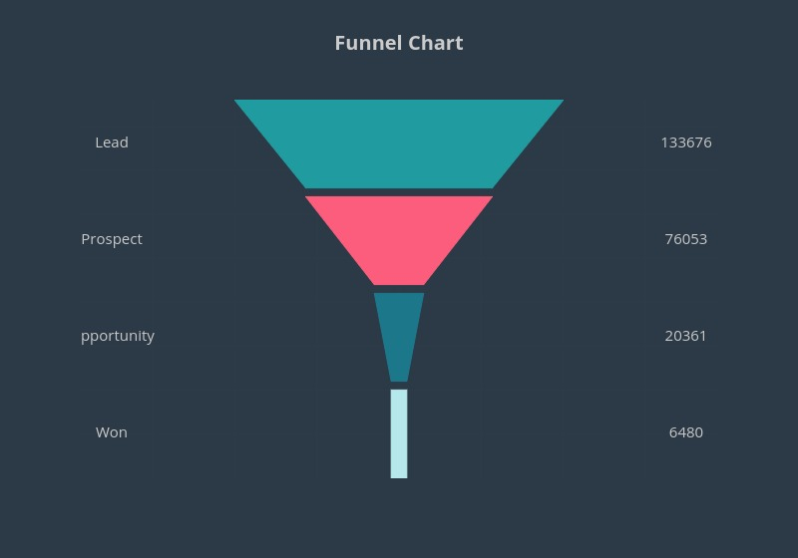

Missing Data
An initial review of the dataset quickly reveals a serious inadequacy in the population of fields in our database. The cell below shows the extent to which valuable fields for our leads are omitted, resulting in tens of thousands of leads in the funnel that are not contributing to sales channel, lead source, business type, lead qualification score, and geographical analysis.
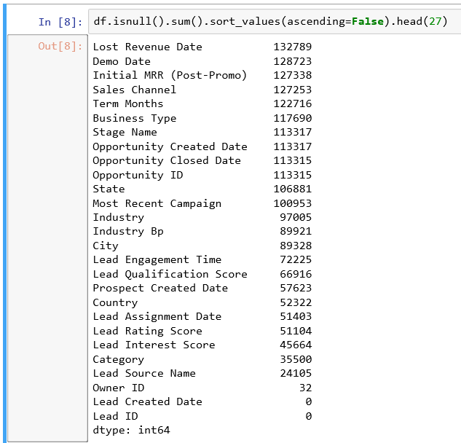
The importance of a complete and accurately populated database of leads cannot be overstated. Before discussing the insights that can be gleaned from the complete data I recommend a review of how we populate our lead management database and encourage recategorizing several fields as mandatory for lead creation as well as reviewing the format of these fields for consistency.
An example of format inconsistency can be found in the “Prospect Created Date” and “Opportunity Closed Date” fields. These are currently populated with a datestamp but no timestamp, whereas the “Lead Created Date” and “Opportunity Created Date” contain a timestamp as well as the date. All four fields from which we extract lead progression data should be formatted consistently if we are to extract accurate data for our time to conversion analysis.

Lead Conversion Rates and Times
Lead Time to Progression
 | Lead | Prospect | Opportunity | Won
Total Count | 133677 | 76033 | 17414 | 6113
% of progression from previous stage | N/A | 56.9% | 22.9% | 35.1%
Mean time to progression | N/A | 2.36 | 5.85 | 7.82
Number of progressions within 1 day | N/A | 64337 | 11459 | 3939
% of progressions within 1 day | N/A | 84.6% | 65.8% | 64.4%
Number of progressions within 3 days | N/A | 71444 | 13393 | 4365
% of progressions within 3 days | N/A | 94.0% | 76.9% | 71.4%

While just over half of all leads generated progressed to Prospect status, less than 23% of those prospects progressed to Opportunity, or approximately 13% of total leads. In the last ten months we have converted ~4.5% of new leads into customers. Here is a breakdown of lead to customer conversion per month:
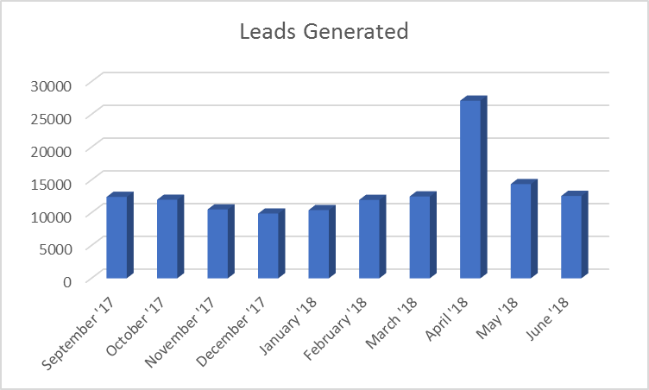
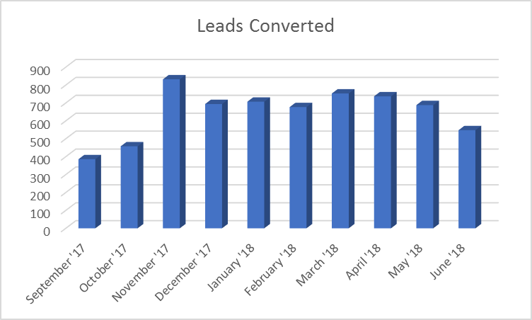
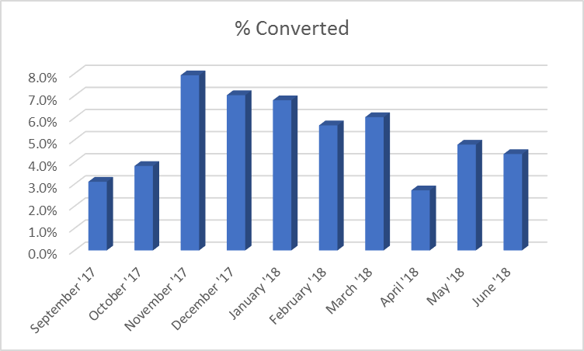
*** NOTE: 13,525 new leads were generated on 4/1/2018, more than the average per month. Only 9 of these leads were converted to customers, adding an anomalous outlier to the data. ***
Lacking the data to compare for seasonality and previous years’ trends makes assessing the significance of these conversion rates as actionable metrics difficult. According to this data we average a 5.2% lead-to-customer conversion per month. The conversion rate average for lead generation in the software industry hovers between 5-10%, according to Capterra. Removing the anomalous 4/1/18 lead generation surge, our monthly conversion rates range from 3.1% to 7.9% with a standard deviation of 1.5% (or 140 leads converted).
Accounting for monthly lead generation rates we are seeing a slight downtrend lead conversion. Continued A/B Testing along the current contact strategy may yield insights into the most effective tactics for lead progression.
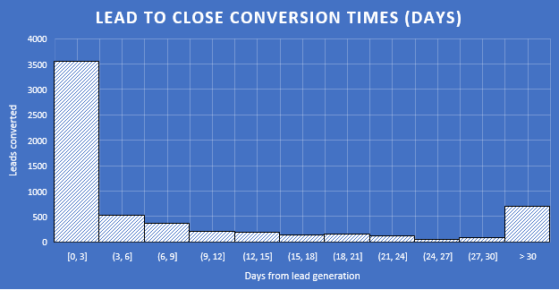
The Lead Time to Progression histogram above shows that 94% of the 6,113 leads that were converted to customers were converted to prospects within 3 days of their lead generation. 77% of those were converted to opportunities within three days. And 71.4% of those were converted to customers in three days. Our average lead generation to close time is 13.1 days. Accounting for outliers (703 leads were converted in >30 days), 4,450 (73%) were converted in 9 days or less with 3563 (58%) being fully converted within 3 days. This indicates a very active sales contact strategy that should be maintained as is, albeit with regular reviews to ensure this operational tempo is retained.

Product Demonstrations
One of the fundamental assumptions of the Keap product line is that entrepreneurs and small business owners lack not only the tools for effective client management, but also the time to develop an ad hoc system of their own. Live demonstrations of the Keap suite of products confirm that the need develop and manage their own tools is unnecessary since we already have the tools they need.
Between October 2017 and June 2018 we conducted 4,936 live product demonstrations for our 76,033 prospects. Of these, 1,439 prospects converted to customers, a full 29% of demonstrations conducted. The value of these demonstrations is clear and more effort must be made to conduct in-person demos where possible as well as to develop and conduct interactive video conference demonstrations where in-person demonstrations are not possible. The need for this is grounded by the following:
- 81,359 leads have a stated country of origin
- 17,867 (22%) of these exist outside the United States
- Only 1,300 (7.3%) of these leads converted
  - 448 (2.5%) product demonstrations were conducted
  - 107 of international leads for whom demonstrations were conducted converted. That’s 23.8% of international leads who were given a demonstration, aligning with the previously stated 29% of domestic conversions.
Additionally, management should consider developing a series of small business mock-ups of our most common client industries that can then be demonstrated by prospects for a limited period. This will allow prospects to acquaint themselves with the functionality and benefits of the tools in a relatable “real world” environment

Lead Sources
From where do we get our leads and from where do we get our sales? Of the 133,676 leads generated from October ’17 through June ’18 a full 98,176 (73.4%) were added with a selection in the Category field. 4001 of the total 6,113 sales came with a selection in the Category field. Ideally, this should be a mandatory field that would provide a 100% accounting, but the need for increased data entry discipline has already been addressed.
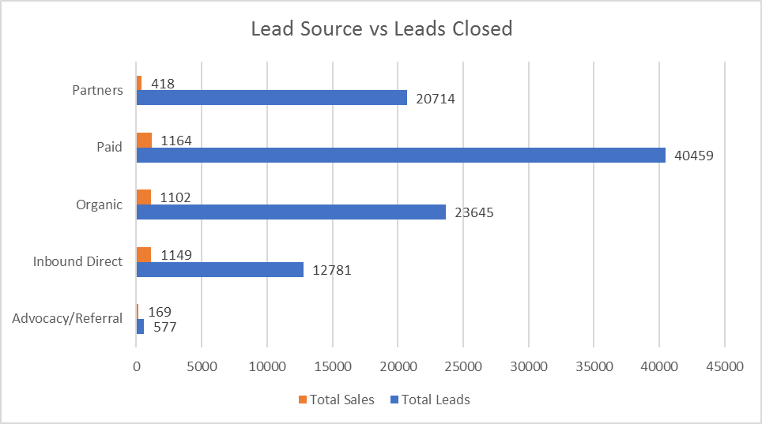
The above graph shows the leads converted vs. their source. As would come as a surprise to nobody with business experience the highest percentage of conversion by far came from Advocacy & Referrals. Over 29% of leads generated by referral were fully converted. However, referrals make up only 577 of the 98,176 sourced leads. By far the largest source of our leadbase comes from paid sources that yielded only a 2.9% conversion rate.
Though the paid lead conversion rate is small compared to the quantity of leads generated, they still comprise 29% of total sourced leads converted. Therefore, it is not advised that we decrease our paid sourcing unless subsequent ROI data shows an optimal investment below the current investment.
However, referrals should be increased. A committee should be assembled to weigh options for offering incentives to current customers for their referrals that convert to customers.

Machine Learning
Identifying factors that correlate to lead conversion rates can be often be accomplished using Machine Learning models. For the data provided some fields provide useful information and others not so much. Columns such as Lead ID, Opportunity ID, and Owner ID offer no insight and are therefore omitted. Other fields that would otherwise be valuable in these models such as Business Type, Sales Channel, and geographical information (City, State, & Country) would be valuable but are too frequently omitted in the database, resulting in a smaller sample size that then degrades the accuracy of the model.
The dataset contains headers, so I’ve trained supervised learning classification models Logistic Regression and Gradient Boosting Classifier using a binary Won/Not Won target. I’ve implemented one-hot encoding for non-numeric fields, removed rows missing data (imputation would have caused more problems than it solved), and split the dataset into an 80% training set and 20% test set.
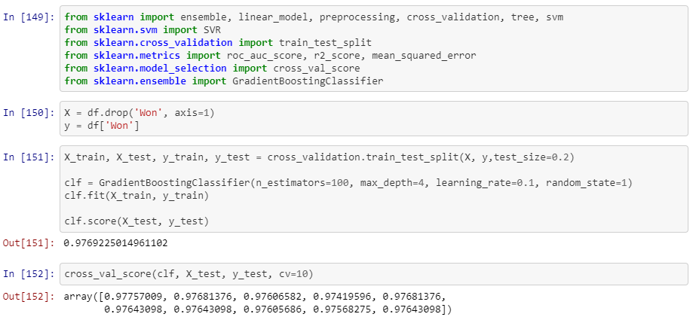
In the end, the high score of the models is attributed to class imbalance. It may be possible to assess the classifier accuracy using a receiver operating characteristic curve or a precision-recall curve. But for now, machine learning offers little insight not already extracted.
The code repository for this and other aspects of the data processing can be found here.

Recommendations
- Increase and improve database completeness and accuracy by making several fields mandatory for lead creation
- Increase A/B testing in lead communications to identify the most effective tactics.
- Increase live product demonstrations where possible and videoconferencing demonstrations where not possible.
- Develop mock-up client databases across a few of the most common industries of our existing customers and distribute to prospects so that they can demo our tools in a way that is relatable to their operations.
- Ensure sales staff are incentivized to operate under a lead contact and conversion timeline to improve average lead conversion time from 13.1 days to 12 days, accounting for outliers where reasonable.
- Convene a committee of stakeholders to consider and quantify incentives for existing customers who refer new leads that convert to customers.

